GEnealogical Data COMmunication- is a way to exchange Genealogical information between software programs

GEDCOM BASICS
FamilySearch does not support GEDCOMS. But FamilySearch links to Ancestry. Ancestry can transport four generations at a time from FamilySearch into Ancestry. Both programs can exchange information, including sources, back and forth with each other. They cannot as yet transport pictures. Ancestry is a good place to start your tree if you don’t have one. The reason is because no one can change information in your tree without your permission, it can link with FamilySearch, the program will find hints and sources for you, and you can GEDCOM it into other data bases. FamilySearch can exchange information between Legacy, Roots Magic and Ancestral Quest. MyHeritage can now bring over 8 generations from FamilySearch. If you already have a tree in MyHeritage it puts it in a different tree. If you change information in either your new MyHeritage tree or FamilySearch Tree, you can go in often and synchronize the two. This is in Beta form now; more functions will be coming in the future.

To IMPORT and EXPORT a tree, go to the program where your tree is, and create a GEDCOM to EXPORT. Once this tree is exported, you can transport it to as many data bases as you like. To bring a tree into a data base, go to the program you want to bring your tree into and click IMPORT. The programs walk you through the steps. If you have the chance to link 2 programs, that is the preferred way.
Ancestry, MyHeritage, Findmypast, PAF, RootsMagic, Legacy, AncestralQuest can GEDCOM genealogical data between each other. Ancestry, MyHeritage, and FindmyPast are partners with FamilySearch. Members of the Church of Jesus Christ of Latter Day Saints can get a free account for all 3 of these. PAF is an older program people used before computers came into wide use. It is not supported anymore but you can convert all your data over into AncestralQuest directly without a GEDCOM. Roots Magic, Legacy, AncestralQuest are free to be downloaded. They are private data bases no one can change information in them except for you. Or if you want more functions, you can upgrade each for about $20. Prices, however, will be going up as they create more and better functions.
GEDCOMS transfer data only. They do not transfer Media. Exceptions are: MacKiev will transport data and pictures from Ancestry (About $29-$90/year. Family Tree Builder will transport data and pictures from MyHeritage. Pictures will go in a separate file. It is FREE
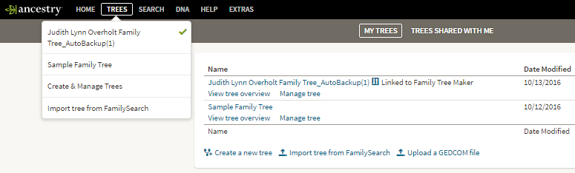
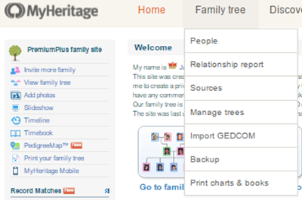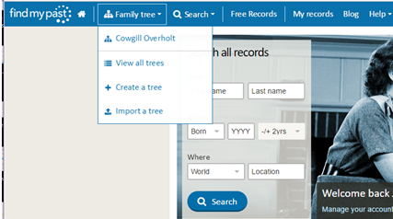
5

MyHeritage
Go to “Manage Trees” to Export
Click on “Export to GEDCOM” by tree. Follow the prompts .Save it to a file.
Click here to Import a tree
It will walk you through the steps
3
8
7
Ancestry : to E To Export: go to “Create and Manage Trees”. On the next screen, click under “Manage tree” beside the tree you want to export. After it downloads, name it and save it to a file.
To Import a tree into Ancestry click on “Upload a GEDCOM file” here
It will walk you through the steps.
2
6

Findmypast
To Export: Under “Family Tree” top toolbar, click on “View all trees” then beside the tree to export, click on this icon to download. Save it to a file.
To import: click here and it will will walk you thru the steps.

.
Judy Sharp Updated 2019
8
4

3
3
7
6
4
5
2
1
1
1
1

