
MyHeritage
Members of the Church of Jesus Christ of Latter Day Saints can get a free account. Do this (once only) by signing into www.familysearch.org/partneraccess and sign in with your LDS account. Click the button “Create FREE MyHeritage Account “ to register and create your free LDS Account. You will log in with the user name and password that you choose each time you access MyHeritage.com. You will get more benefit out of MyHeritage if you include your tree. If you have your tree in another program, (other than FamilySearch) you can use a GEDCOM to transfer your tree over into MyHeritage. If not, you can type in the names of 3-4 generations starting with you and let the program find the rest of your ancestors. Or if member of the Church of Jesus Christ of Latter Day Saints, you can link 8 generations into MyHeritage from FamilySearch. It will create a new tree and you can continue to link as you add more information to FS.


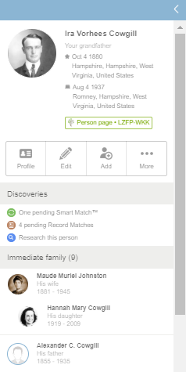
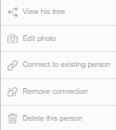
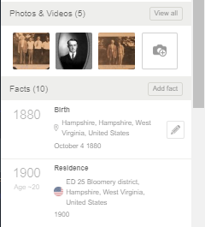
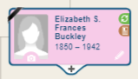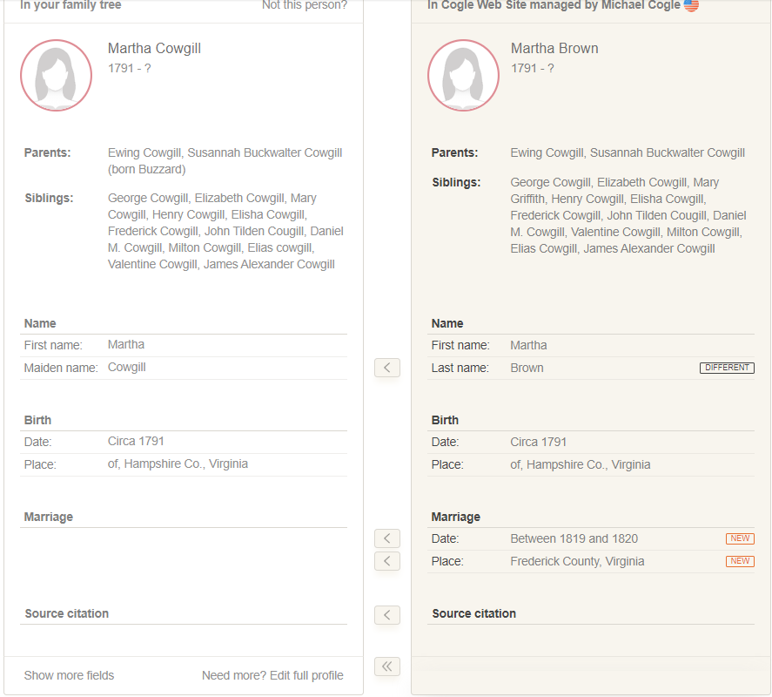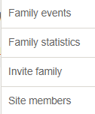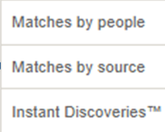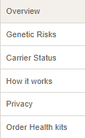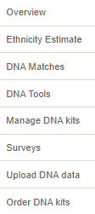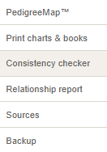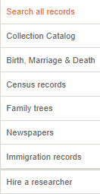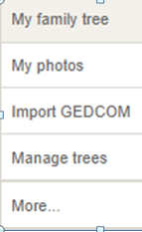
<<
<
<
<
<
Green Circle indicates a “Smart Match” which means there are one or more family trees that may match your tree. 1-click on green circle; 2-review match; 3- confirm match if it is; 4 –your tree on the left and other tree is on the right. Move information and people over if desired by clicking the arrows between the two records; 5- When finished, click on “Save to tree” bottom right. Or at the very bottom you could extract all the information with one click. You can also compare the pedigree view of their tree next to yours at the bottom. (Not shown)
PedigreeMap show where your ancestors lived. Consistency Checker identifies data problems in your tree. Under Home tab, Family Statistics are fun facts about your tree.
From the people tab in your tree you can add a photo, add relatives from the + sign, pencil icon lets you do a quick edit or you can go directly to Smart Matches or Record Matches
SUMMARY BOX-by clicking under a name in your tree, will bring up this box. See FamilySearch PIN
Go to their Profile, do a quick Edit, Add family members
Go directly into “Smart Matches” or “Record matches” or “Research this Person” will take you to “Super Searches”.
Under “More” you can view tree, edit photo connect to existing person, remove connection, delete this person.
You can “Add a photo” or a fact.
Hovering your mouse over a fact will bring up a pencil icon, click on it to edit.


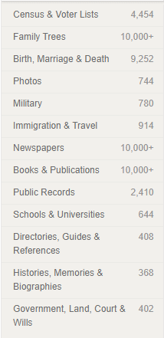
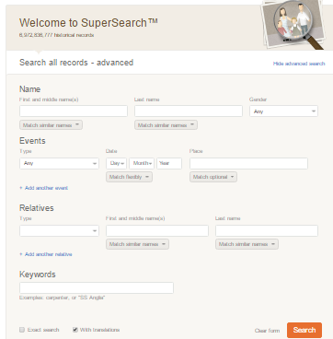
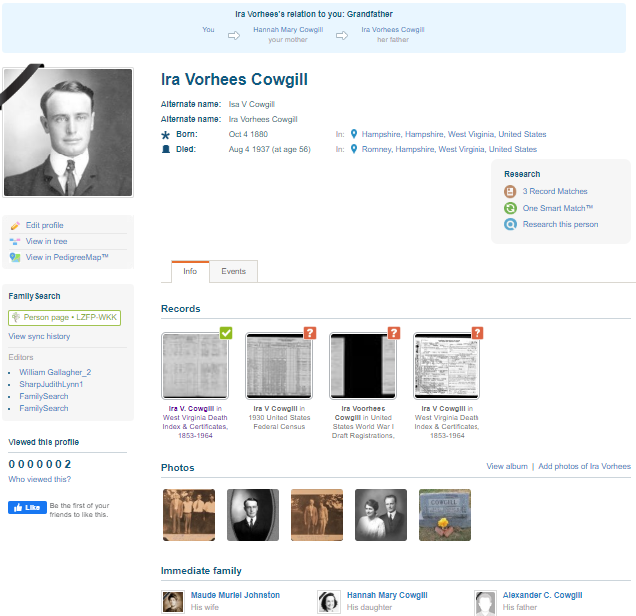
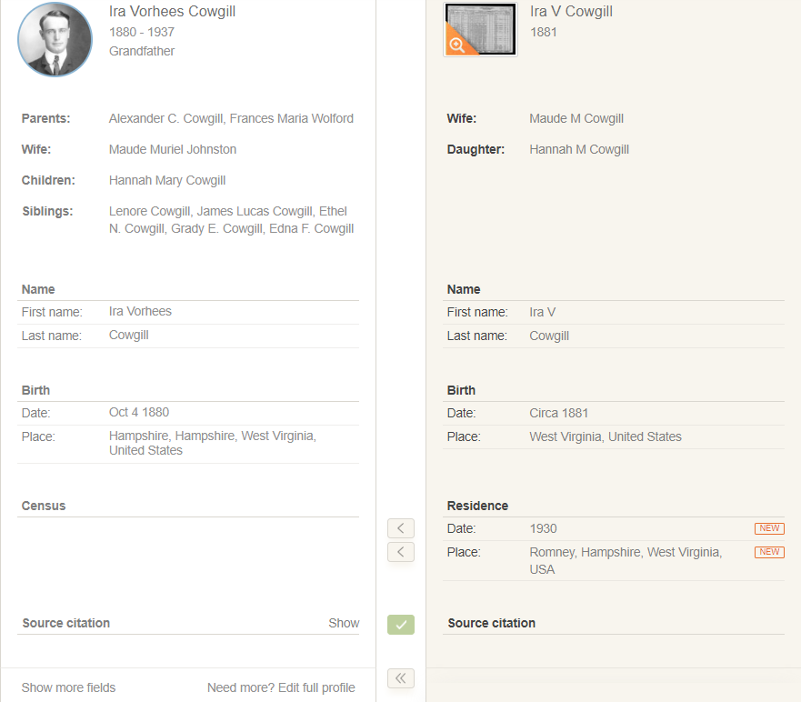
To see a video on this and other basics, google “byufhl Family History Basic Tutorials”
<<
<
<
See your relationship to this person
Go directly to “Smart Matches” or “Record Matches” or “Research this person” will take you to SuperSearches
Add a photo here or view an album
See their family members; spouse, children, parents and siblings.
Very bottom of Profile page (not shown) you can add education, work, favorites, personal info, biography and web links including videos.
PROFILE PAGE- Click on “Profile” from the summary page to get here.
Do a quick “Edit” to the Profile, “View in Tree” or “View in “PedigreeMap”
See FamilySearch PIN
Under records, these are sources. A green check mark means they are already confirmed and in your person’s sources. A brown question mark means they are ready to be added once you review them.
Click on “Edit” by” Source Citations” to edit a source. Or click on “Add another Source Citation” seen at end of list, if it is not found in MyHeritage, and enter manually.
Judy Sharp- Updated January 2020
SuperSearch is the main research place. If you are searching from a profile page all the information of the person is automatically populated. If the person is not in your tree, you can type in the information. Clicking on the drop downs under an information box will allow you filter more results. “Results” tab will bring up all information, but the “Summary” tab will group them into categories. Or you can filter by clicking on a category and just look for photos or birth, marriage and death records for instance. Make sure you have a check mark beside “With translations” so if you are researching in a foreign language, the program will translate it to your language.
Record Matches are official government or church records that can verify birth, marriage, or death for a person. 1-Click on a brown circle to see the records 2-Choose a record and click on “Review Match”; 3- Look over the match; look at the original and if it looks right, click on “Confirm Match”; 4-Like Smart Matches, you can bring information over from the record over into your tree by clicking on the arrows between your tree and the source. Be sure to always bring over the source citation. 5-Click on “Save to Tree”.

